Bami, Alusayne and Yusuf  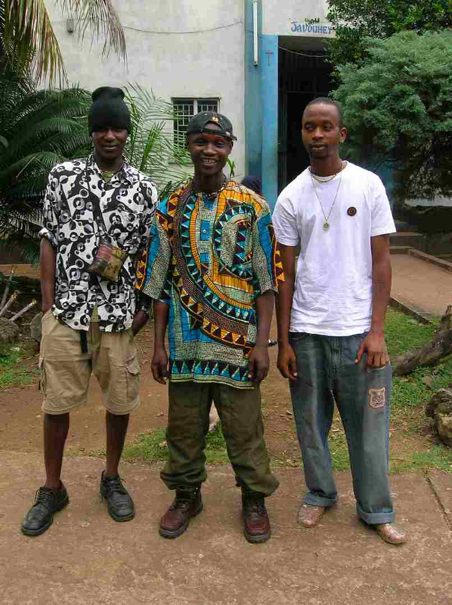  Youth |  | 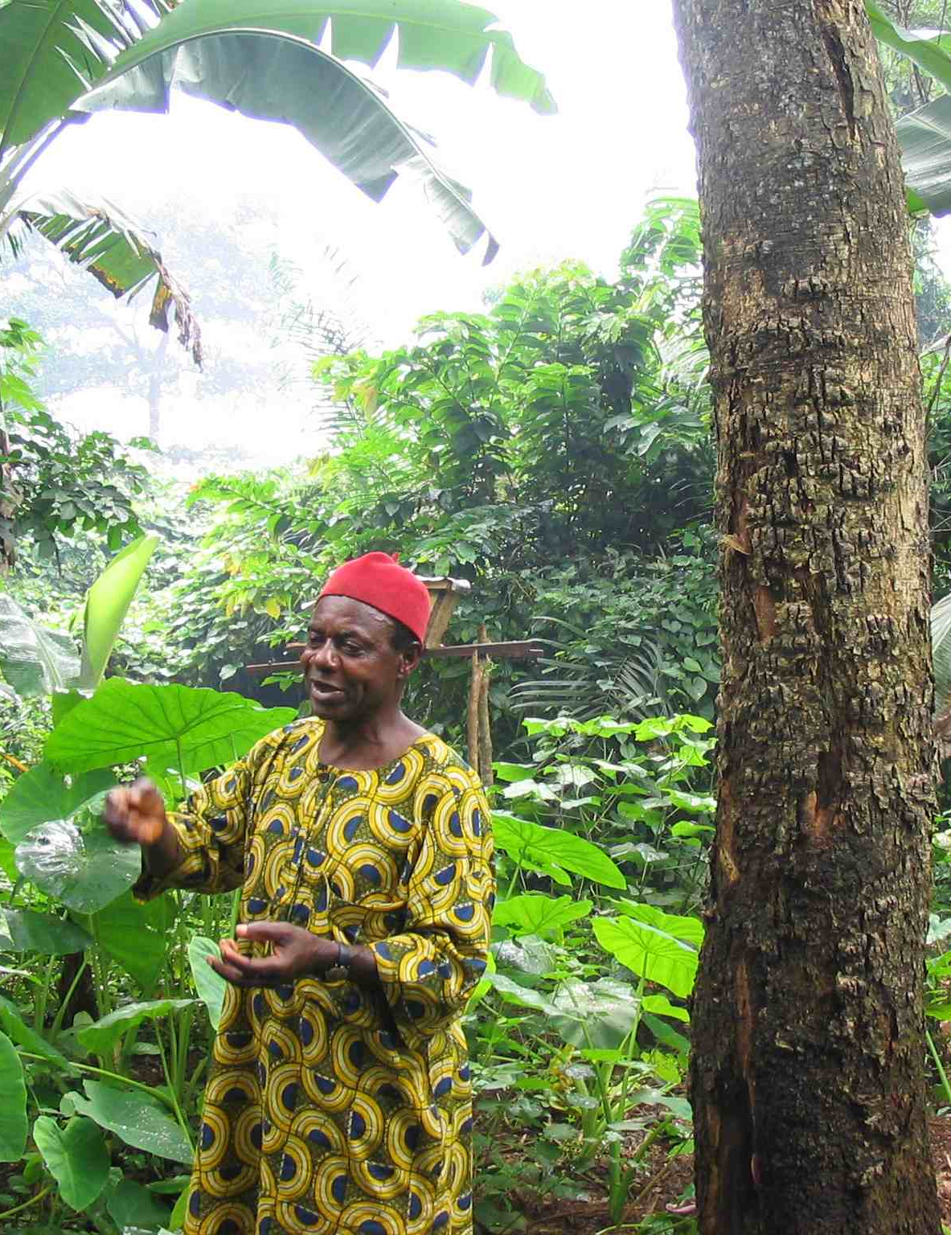  Chief Omong
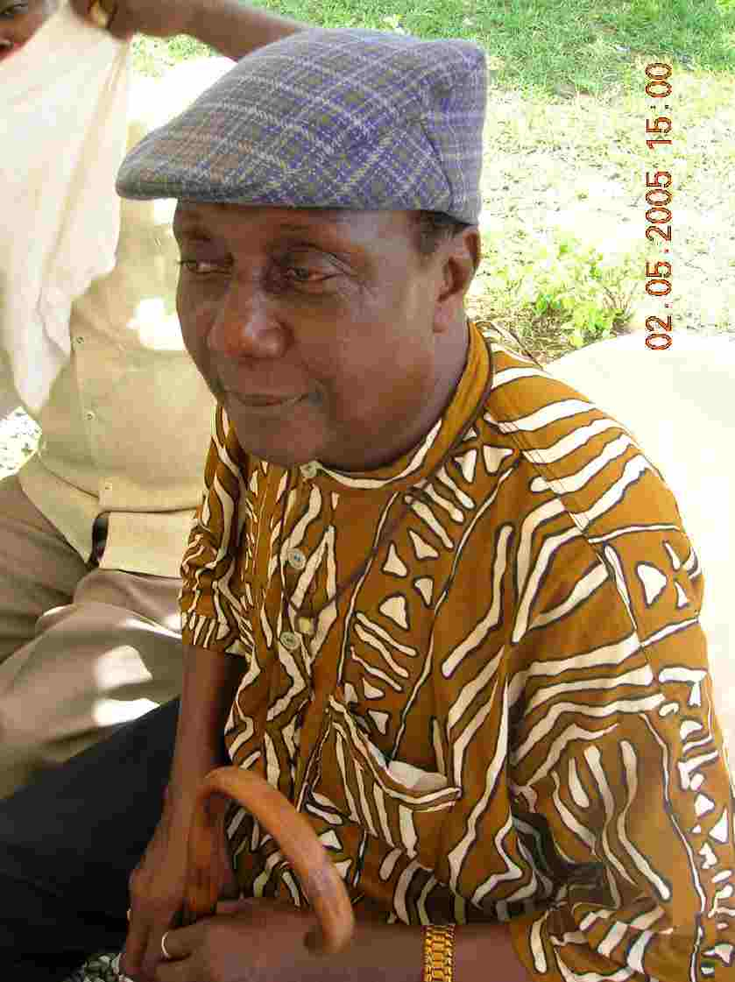  Mr. Victor Massaquoi  Elder |  | 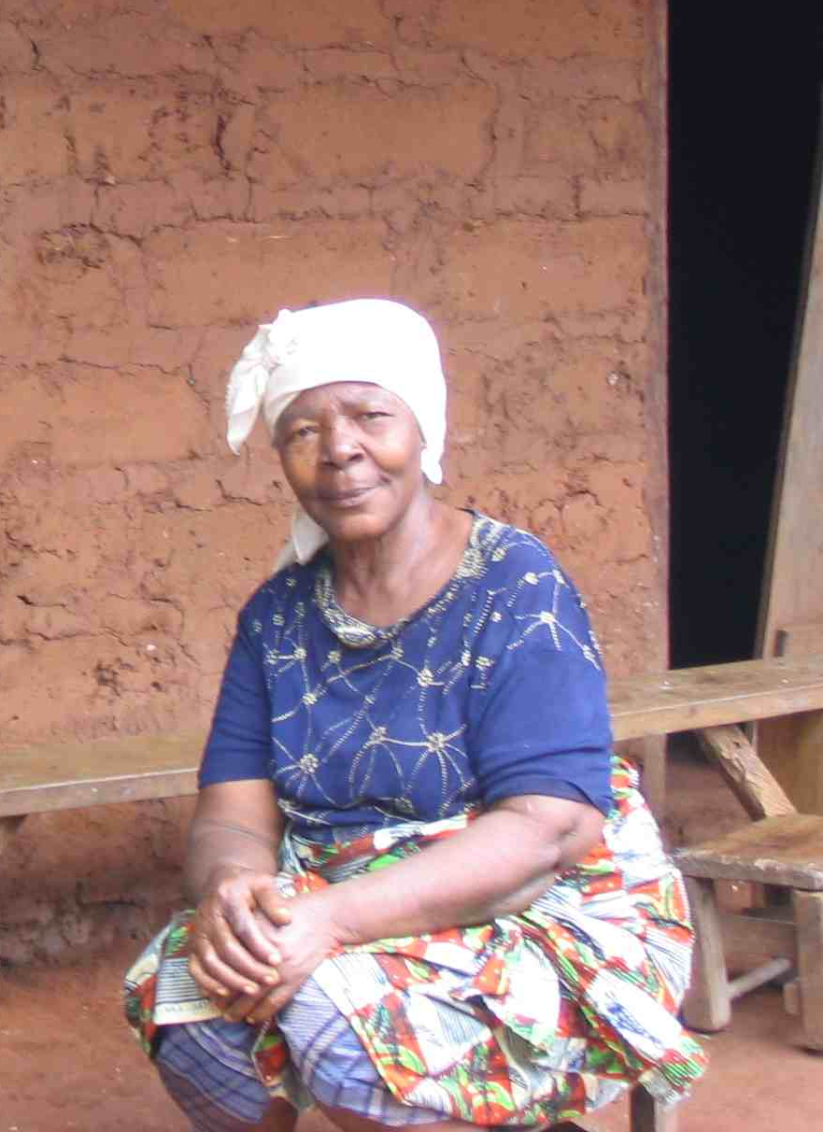  Mrs. Sia Tengbe  Elder

