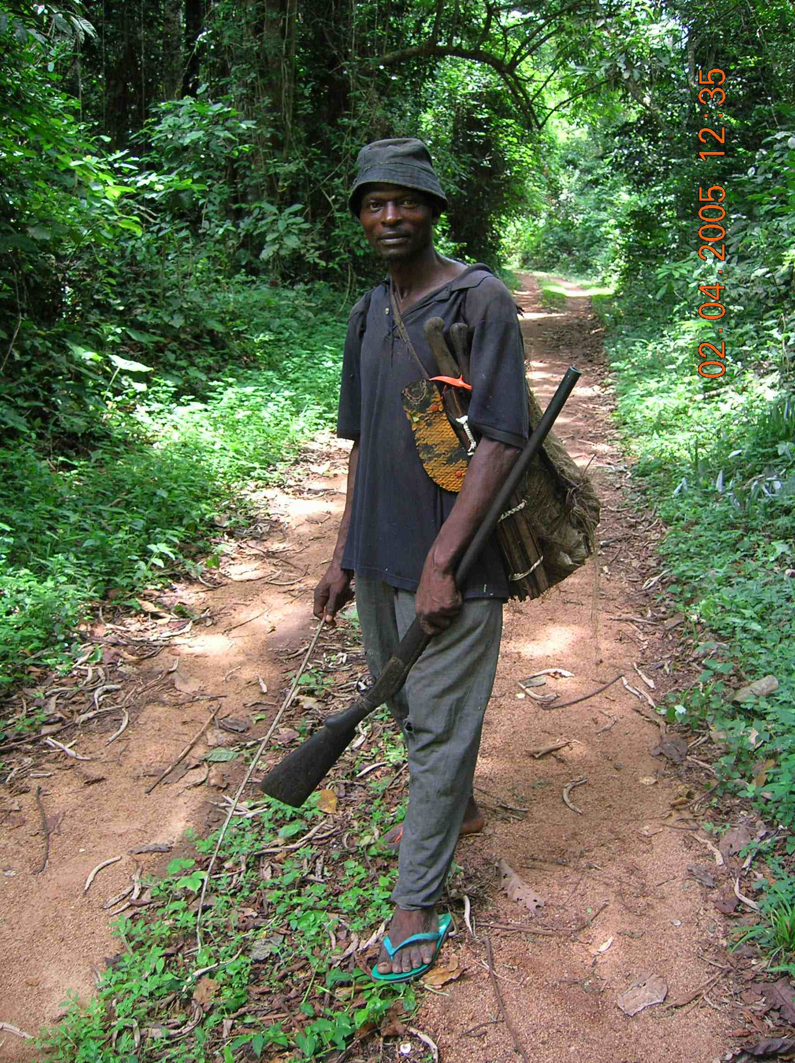  Sahr Koroma  Hunter |  | Lansana Conteh and  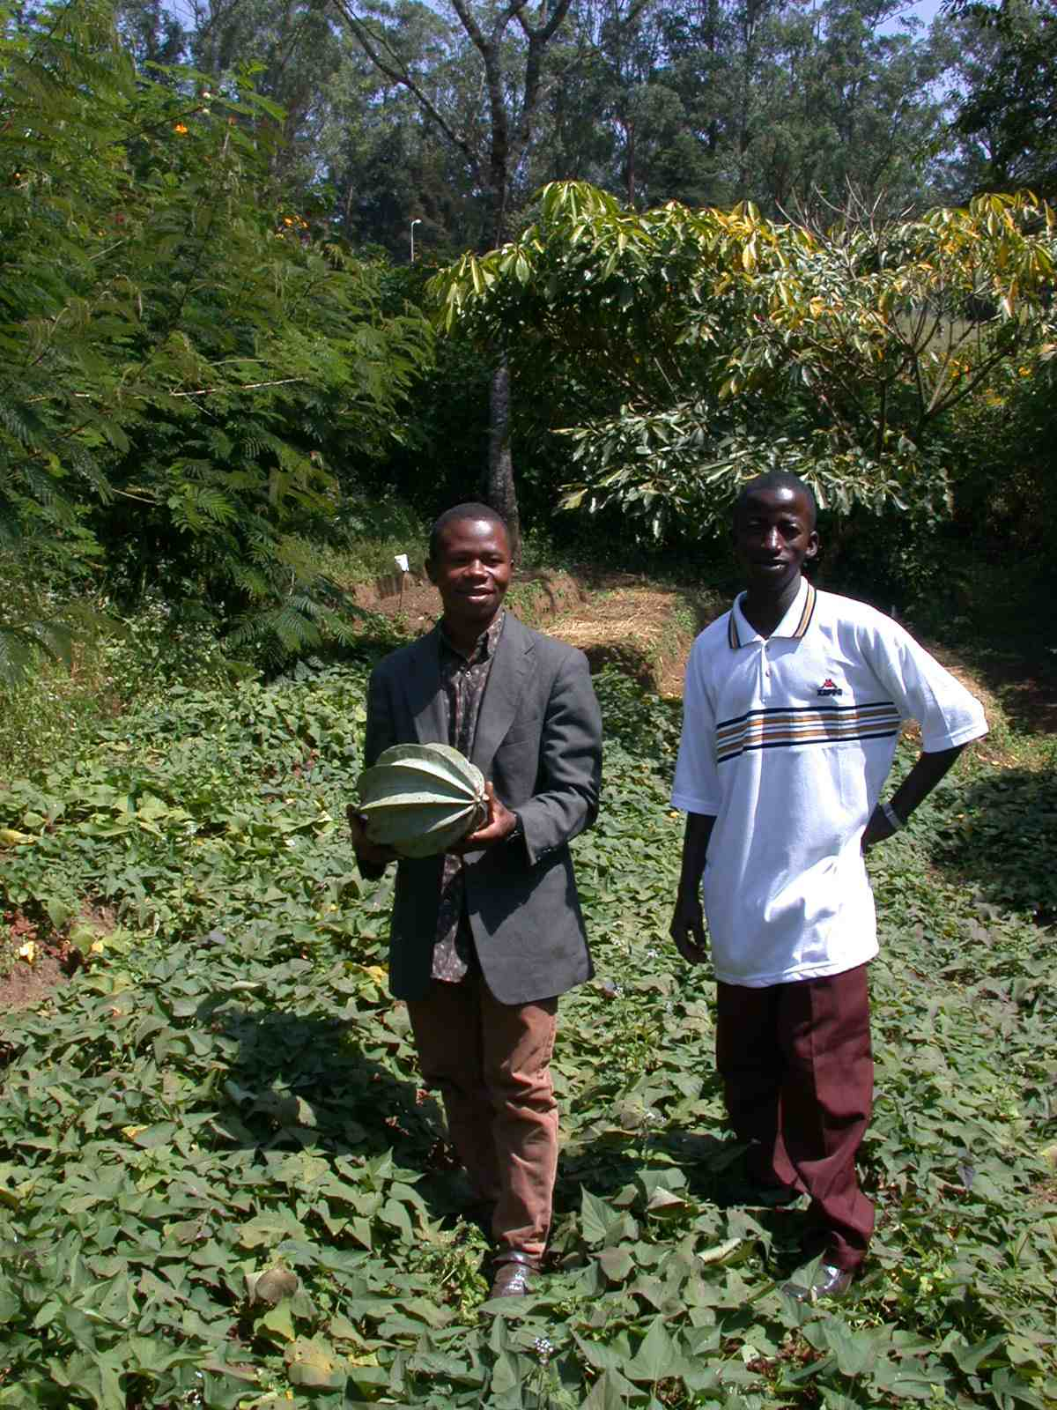  Mohammed Bangura  Farmers
Mariatu Kargbo and  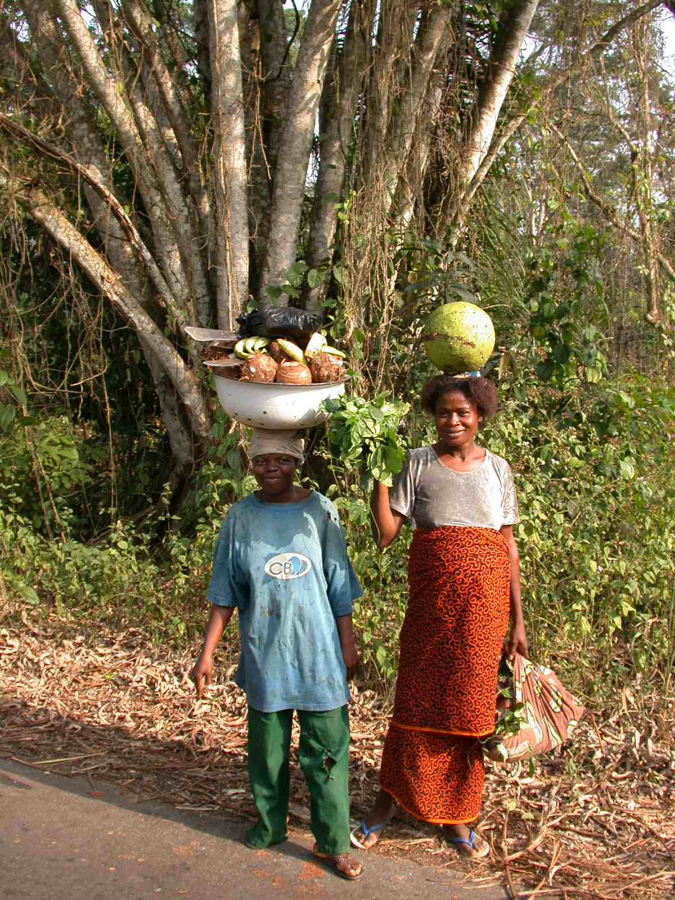  Hawa Siaffa  Forest Harvesters |  | Alimamy Karim  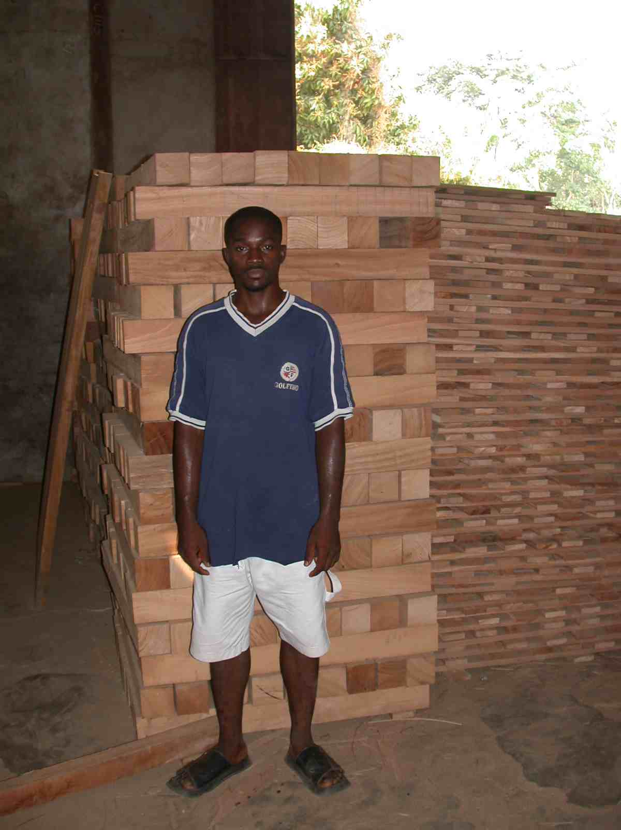  Logger

